**Scenario Questions**

1. Have you reviewed AHS’ budget and finance-related documents as provided on the agency’s website? What do you identify as strengths in the AHS budget and what are areas of deficiency?

Yes, I have reviewed the finance-related documents from the agency’s website.

Weaknesses

As noted in the SWOT analysis, donor, operational budget, lack of state legislature support, infective solicitation and outreach, internal communication/cohesion breakdowns, pattern of emergency repairs.

Strengths

Subject matter experts in their field, ability to have the outreach if effectively utilized, and the understanding of problems current with organization (self-aware)

2. Scenario: As the agency’s CFO, you will be tasked with navigating budget challenges. Given the possibility of not receiving the approximate $1.5 million appropriation increase in its FY25 request, we need a comprehensive strategy. Please provide a detailed plan, complete with a spreadsheet, outlining specific changes you would make to the proposed budget to maintain a budget-neutral status. In your plan, consider revenue adjustments, cost-saving measures, and how you would protect our mission. Walk us through your thought process and the key financial decisions you would make.

Key topics: Why was 2019 such a successful year as opposed to 2020 – 2021, What was done at Tempe in 2022 to increase visits by 90% from previous year, and from there corporate sponsorship initiatives. Things observed is without the appropriated funds of $1,449,220 FY2025 would be estimated at taking their working capital to 0.754.

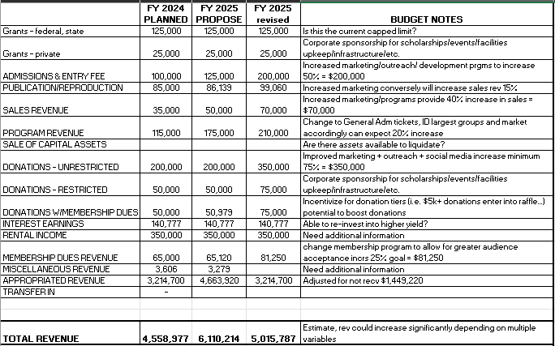

3. Analysis: Please provide an itemized list and plan of action in your first 30 days.

In the first 30 days the goals are to complete an OODA loop or DMAIC to have a clear and consistent picture on how to establish end goal objectives (net neutral). A gimba walk would be requested during the first week to better understand the RCA of problems faced at each installation. Since communication has been highlighted as a severe problem throughout the organization it would be critical to establish open lines of communication and provide a clear picture to all installations on the goal moving forward.

List of priorities:

1. Establish discount rates for programs to provide better outreach.
2. Consider local or national corporate sponsorship programs.
3. Improve marketing techniques.
4. Seek out military sponsorship agreements (local communities).
5. Look into getting more volunteer staff to supplement workloads throughout the year.
6. Look into the benefits package to seek out alternative methods for reduced costs.
7. Establish CPI events at each location to ensure root problems are addressed in a proactive versus reactive manner.
8. Lastly, implement budget cuts/reallocation of funds to critical assets first that have the highest ROI.
9. Currently we have a less than ideal working capital (2020 = 1) (2021 = 1.3) (2022 = 1.159) and (2023 = 1.12) with 2024 currently forecasted at 0.911 (quite fitting).

Basic Level 30-day Action Plan (chart)

